Project Overview & Architecture
This project demonstrates a complete professional data workflow, structured into three core tiers:
- ETL & Data Hygiene (Power Query): Cleaning raw records, trimming whitespace, imputing missing values, parsing strings, and merging relational tables.
- Data Modeling (Star Schema): Establishing an optimized relational schema with explicit fact and dimension tables linked via 1-to-many relationships.
- Business Intelligence & DAX (Power BI): Developing an executive dashboard driven by advanced aggregation and time intelligence measures.

1. Power Query Transformations (ETL Pipeline)
The raw datasets (Dirty_Sales_Data.csv and Category_Managers.csv) underwent transformation via Power Query before modeling:
- Text Parsing (Region Extraction): Extracted geographical location clean out of raw customer strings using custom logic:
Code snippet
Text.Trim(Text.AfterDelimiter([Customer_Info], "-"))
- Text Standardization: Applied Trim and Clean operations across text fields (Product, Category, Region) to eliminate hidden non-printable characters.
- Null Value Imputation:
  - Imputed missing Quantity values with default 1.
  - Standardized missing Discount_Code records to "NONE".
  - Filled missing numeric prices via lookup alignment.
- Feature Engineering:
  - Calculated row-level Total_Amount (Price_PKR * Quantity).
  - Mapped text discount codes (DISC10, DISC15, DISC20) to explicit decimal rates (0.10, 0.15, 0.20).
- Relational Integration (Merge Query): Executed a Left Outer Join between sales data and Category_Managers on Category to seamlessly embed Manager_Name into the transactional dataset.

2. Data Model (Star Schema)
The data model adheres strictly to modern dimensional modeling best practices:
- Central Fact Table (fact_sales): Houses transactional foreign keys (Customer_ID, Product_ID, Order_Date) and core numeric measures (Sales_PKR, Quantity).
- Outer Dimension Tables:
  - Dim_Customers (Customer attributes and segmentation)
  - Dim_products (Product catalog, categories, and managers)
  - Dim_Date (Custom DAX-generated calendar table marked officially as a Date Table)
- Relational Integrity: Configured strict 1-to-Many ($1:*$) relationships with single-direction filter propagation flowing securely from the dimension lookup tables down into the central fact table.
Visuals:
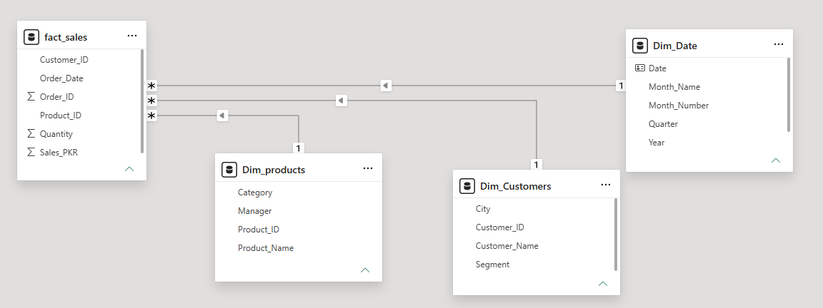

3. DAX Measures Library
All business logic is stored centrally inside an explicit “_Measures” calculation table:
- Total Sales:
Code snippet
Total Sales = SUM(fact_sales[Sales_PKR])
- Total Quantity Sold:
Code snippet
Total Quantity = SUM(fact_sales[Quantity])
- Total Orders (Unique Count):
Code snippet
Total Orders = DISTINCTCOUNT(fact_sales[Order_ID])
- Average Order Value (Safe Division):
Code snippet
Average Order Value = DIVIDE([Total Sales], [Total Orders], 0)
- Year-to-Date Accumulation (Time Intelligence):
Code snippet
Sales YTD = TOTALYTD([Total Sales], Dim_Date[Date])

4. Executive BI Dashboard & Business Insights

Dashboard Structure
- KPI Header Cards: High-level summary metrics (Total Sales, Total Orders, Average Order Value, Total Quantity).
- Multi-Angle Visuals: Donut chart for customer segmentation, line chart for monthly sales trends, and bar charts for category performance.
- Granular Matrix Grid: Hierarchical customer-to-product breakdown cross-filtered by a dynamic date slicer.

Key Business Insights
- Revenue Concentration: Home Decor drives the vast majority of enterprise revenue ($175K+), establishing it as the core product engine.
- Customer Segmentation: Corporate and Retail sectors represent the highest share of transaction volume and sales value.
- Sales Velocity: Transaction patterns show distinct volume spikes early in the month followed by steady mid-period stabilization.
Visuals:
